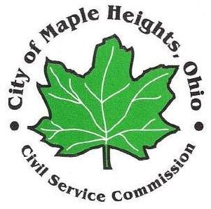

## PUBLIC NOTICE

## Meeting of the Civil Service Commission

Notice is hereby given to the general public of the next scheduled meeting of the Civil Service Commission for the City of Maple Heights.

The meeting will be held on **Monday, August 21, at 12:30 p.m.** The meeting will be conducted in the 1st floor Conference Room of City Hall located at 5353 Lee Road.

Agenda:

* Police entrance exam - eligibility list certification
* Fire entrance exam
* Any other business to come before the Commission

Should any person require special accommodation, please contact Letitia Linker at 216-587-9003 at least forty-eight hours prior to the meeting.